The karate data shows the division of data in two groups on node 1 and 34. Graphs are plotted using ‘karate.gml’ first with scaling 55 and no overlap “Force-Atlas 2” plot which is shown on left most side. The colors of the nodes are based on the betweenness centrality. The network diameter of the undirected plot is 5. The right-side graph is generated using ‘Fruchterman’ which also shows clearly data is centered around two points 34 and 1. Under faction of 34 we have rest of data centered around 33 or is closer to it. Betweenness-centrality is highest for node 34 which is 0.437 and for second highest for node 1 with value 0.34.

**Part 2: Florentine Marriages:**

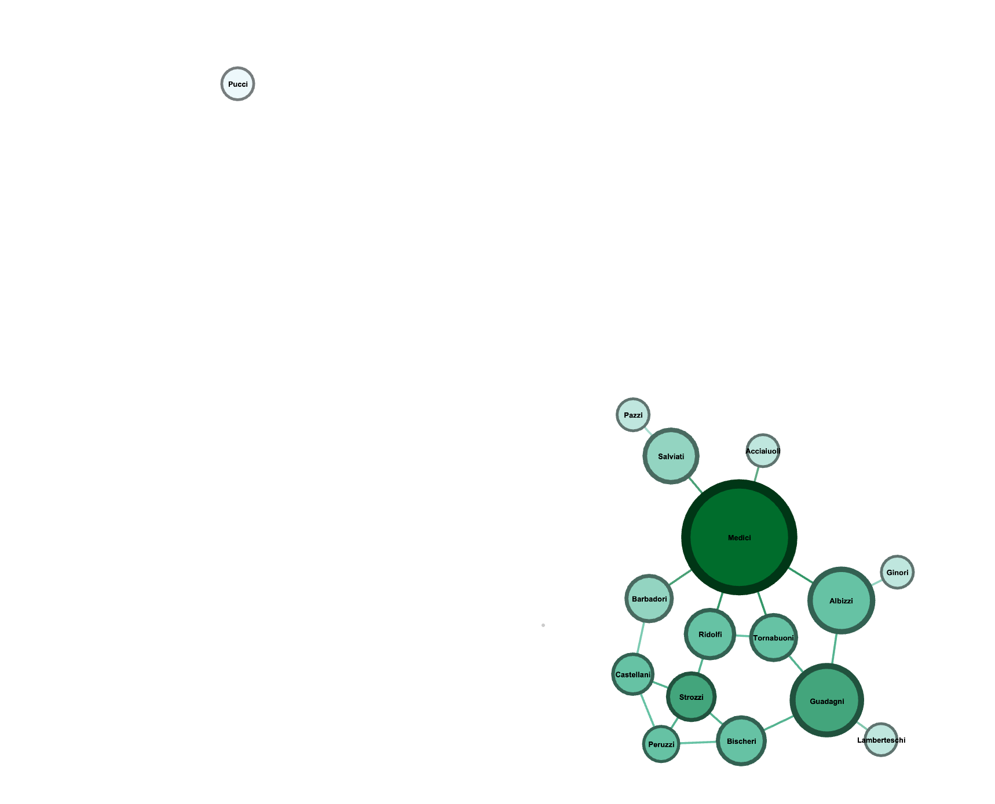

For Florentine marriages dataset the graph shows different families and how families are linked with other families. The graph shows that Medici family is well connected with other families based on ForceAtlas2 plot. The color and size of the plot depicts the betweenness centrality and degree of the nodes. Medici family has the highest of both as the size of the node is big and color is also darkest. Family Pucci is most disconnected family.